# Reflection

I found this final photo essay to be a challenging but ultimately rewarding project and foray into visual storytelling.

Besides actually shooting good photographs, one of the toughest aspects in my experience was simply putting myself in awkward positions. Although there were some events where I felt inconspicuous as a photographer, such as the city council meeting or during the speech at the campaign rally, there were other occasions when I felt out of place or even a little bit rude, such as during P.G.'s staff meeting or at the post office. I actually ended up taking a break from shooting to help P.G. apply some of the stamps at the post office, as I just didn't feel right shooting endless redundant photos while he was working through a massive stack of envelopes. Shooting in uncomfortable situations is something that I suspect will become easier for me with more experience.

I did feel that I did pretty well in terms of finding good shots. I was particularly pleased to get a good shot of P.G. framed in by a sea of blurry faces at the political event (photo #13), as I spent a decent block of time angling for just that one shot. I was also happy with the shot of him imitating his baby George (#11), as it provided a good opportunity to talk about his home life a little bit.

There were a few photos that I really liked visually, but I simply couldn't work them into the narrative. One shot I particularly liked from the political rally (pictured right) featured a massive pallet of cans providing leading lines towards P.G. as he talked with someone; however, I already had so many photos from that event and I simply couldn't figure out a way to work it into the narrative.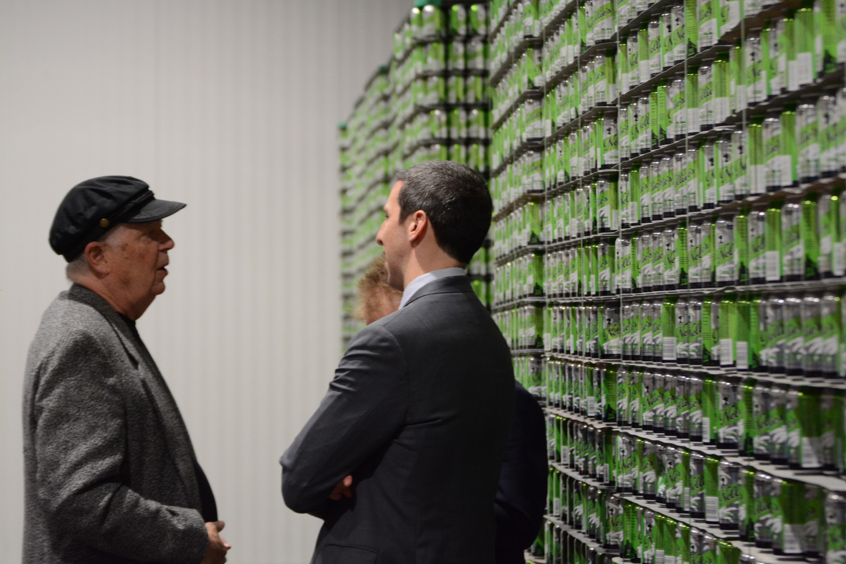

There are also a lot of shots that I wish I could have done better on. The Pledge of Allegiance shot (#2) works well enough as I used it, but I really wish I had had time to frame it a little better and perhaps shoot from a different angle. I also wish I had been more diligent about getting establishing shots. I had an establishing shot at the post office that ultimately didn't make the cut because it wasn't very interesting; I wish I had framed it so that you could see more of the massive USPS building. I talked about how historic City Hall is in the caption for photo #2; I realized as I was writing how perfect an exterior shot of City Hall would have been for that info.

As I expected, there were a lot of shots that I planned for in advance but was unable to shoot on the actual day. I had really hoped to get a shot of P.G. in his messy car, but that day he was driving a different car. I considered mentioning something to the effect of, "it would be messy if he hadn't just bought a new car", but I found out that he still has the messy car and by chance was driving a different car that day. Ultimately, it was too complicated to try to cram into a caption, so I dropped it. I had also hoped to catch him in the act of taking a selfie with someone, but he never took any selfies that particular day (I checked his Twitter account to confirm that there wasn't a selfie that I simply missed).

Overall though, I'm pretty happy with the final product on this assignment. I was very fortunate to have access to such an ideal subject for this assignment, and I feel I made good use of the opportunity.

# Captions

As his campaign ads will tell you, Cincinnati City Councilmember P.G. Sittenfeld is always on the move. Seen here in his Subaru Forester, Sittenfeld spends much of his day on the road as he travels between home, City Hall, speaking events, and meetings.

The city council holds weekly sessions in their chambers at Cincinnati City Hall, a 126-year-old building located towards the western end of downtown. Each meeting begins with all members reciting the Pledge of Allegiance. To Sittenfeld's left is Chris Seelbach, one of his fellow Democrats on council.

Sittenfeld has been serving on city council since 2011, when he became the youngest person ever elected to the city's legislature. Since then, he has been re-elected twice as the top vote-getter, and many local news reporters predict that he will run for mayor in 2020.

As the meeting nears its conclusion, Sittenfeld consults with councilmember David S. Mann during a discussion about city finances. Mann, a long-time local politician who once represented Ohio's first district in Congress, has been serving on council since 2013.

Immediately following the council meeting, Sittenfeld heads to his office in City Hall to debrief with his staff. Located down the hall from the council chambers, the office is just big enough to house his three-person staff.

Sittenfeld's chief of staff Chris Dalton looks up a document on his phone as the team plans for upcoming events. A graduate of the University of Cincinnati, Dalton has been working various aide and campaign management roles in Ohio politics since 2011.

Jasmine Coaston, seen on the left, has served as Sittenfeld's Director of Community Affairs since January. Having previously worked at Cincinnati Public Schools and various youth facilities, Coaston shares Sittenfeld's interest in educational programs. Before he was a councilmember, Sittenfeld was a co-founder at the Community Learning Center Institute, a group which seeks to make Cincinnati schools serve as community hubs for their respective neighborhoods.

After wrapping up with his staff, Sittenfeld heads to the nearby USPS Distribution Center to send out mail to some past donors. After deciding which stamps to buy (he went with the "John Fitzgerald Kennedy" and "1969: First Moon Landing" sheets), he sets up at a table to work through his pile of envelopes.

Having wrapped up his business downtown for the day, Sittenfeld heads to his home in East Walnut Hills. He has a few hours of work to get done ahead of two political rallies in the evening.

Sittenfeld grabs a quick slice of pizza for dinner shortly after arriving at Taft's Brewpourium for Jill Schiller's campaign kick-off event. He chats with David Pepper, chairman of the Ohio Democratic Party, and Carolyn Gilbert, president of a local marketing and research company.

As anyone following his social media accounts knows, P.G. Sittenfeld is the proud father of George, his newborn baby of five months. Here, P.G. re-enacts George's less-than-positive reaction to certain foods. Looking on are Pavan Parikh, a former candidate for judge of the Hamilton County Court of Common Pleas, and Crystal Dandridge, a West Chester-based political consultant.

Sittenfeld serves his role as presenter for the night, introducing treasurer candidate Jill Schiller to a small but enthusiastic crowd of local Democrats. In his speech, Sittenfeld praises Schiller for her hard-fought (though ultimately unsuccessful) run for representative of Ohio's 2nd congressional district in 2018.

Following a stump speech from Schiller, the room settles down and Sittenfeld resumes mingling amongst the crowd. Sittenfeld is a quintessential extrovert and works the room with ease.

Sittenfeld and his chief of staff Chris Dalton speak with Bonnie Dunkelman, executive co-chair of the Hamilton County Democratic Party, as they make their way out of the Jill Schiller event around 7 p.m. Sittenfeld would go on to speak at another event that night before retiring at the end of a long day.